Cell metabolism disturbances and accumulations

Glycogen infiltration (INTRACELLULAR ACCUMULATION OF GLYCOGEN)
-Excessive intracellular deposits of glycogen are seen in patients with an
abnormality in either glucose or glycogen metabolism.
- Accumulation of glycogen in tissues that do not contain glycogen under normal conditions
-The liver is the normal site for storing glycogen, and the muscles, skin and heart contain amounts of glycogen and are found in some other fetal tissues
- Glycogen infiltration appears in some tumors, some infections and around necrotic tissues
-Glycogen deposits in diabetes mellitus are seen in epithelium of distal portion of proximal convoluted tubule and descending loop of Henle, in the hepatocytes, in beta cells of pancreatic islets, and in cardiac muscle cells.
- The accumulation of glycogen in the kidneys is due to the reabsorption of glycose from the urea, but it is difficult to explain its accumulation in the heart muscle.
-In glycogen storage diseases or glycogenosis, there is defective metabolism of glycogen due to genetic disorders. in these diseases enzymatic defects in the synthesis or breakdown of glycogen result in massive accumulation, causing cell injury and cell death.

Macroscopic appearance
- Glycogenic infiltration cannot be seen visually in the tissue, but if the amount is large, the organ is enlarged and pale in color.
Microscopic appearance
-the glycogen masses appear as clear vacuoles within the cytoplasm. Glycogen dissolves in aqueous fixatives; thus, it is most readily identified
when tissues are fixed in absolute alcohol.
- To clarify the glycogen in the sections should
- 1- The use of absolute alcohol in the preparation of the fixation instead of water .
- 2- Staining with Best carmine or the PAS reaction imparts a rose-to-violet color to the glycogen, and diastase digestion of a parallel
section before staining serves as a further control by hydrolyzing
the glycogen

Prognosis
- Glycogen infiltration is not dangerous for cells or organisms
Cholesterol Deposits
- The cellular metabolism of cholesterol is tightly regulated such that most cells use cholesterol for the synthesis of cell membranes without intracellular accumulation of cholesterol or cholesterol esters.
- It is the deposition of cholesterol at the sites of cellular necrosis in tissues, especially at the sites of old chronic bleeding and old chronic abscess, which are fenced with fibrous capsules.
- Intracellular deposits of cholesterol and its esters in macrophages
may occur when there is hypercholesterolemia. This turns macrophages into foam cells.
Macroscopic appearance
- This pathological change cannot be observed visually in the tissue, but sometimes solid nodules can be seen in the lateral ventricles of the brain with hemorrhage.
Microscopic appearance
- In atherosclerotic plaques, smooth muscle cells and macrophages within the intimal layer of the aorta and large arteries are filled with lipid vacuoles, most of which are made up of cholesterol and cholesterol esters. Such cells have a foamy appearance (foam cells), and aggregates of them in the intima produce the yellow cholesterol-laden atheromas characteristic
of this serious disorder. Some of these fat-laden cells may rupture, releasing lipids into the extracellular space.
- The extracellular cholesterol esters may crystallize in the shape of long needles, surrounded by a fibrous capsule.
- in Xanthomas. Intracellular accumulation of cholesterol within macrophages is also characteristic of acquired and hereditary hyperlipidemic states. Clusters of foamy cells are found in the subepithelial connective tissue of the skin and in tendons, producing tumorous masses known as xanthomas
-in Cholesterolosis. This refers to the focal accumulations of cholesterol-laden macrophages in the lamina propria of the gallbladder.
- Niemann-Pick disease, type C. This lysosomal storage disease is caused by mutations affecting an enzyme involved in free cholesterol transport from the lysosomes to the cytoplasm and resultant accumulation in different organs especially in the nervous system.
- the cholesterol deposited in tissue when the macrophages engulfing and destruction the red blood cells in the tissues(hemorrhage ) outside the blood vessels, and when these cells die, they release cholesterol, from its wall.
Prognosis
- Since cholesterol is a tissue-stimulating substance, it is surrounded by a fibrous capsule , which leads to the appearance of nodule-like structures and when they appear in the brain may lead to death.

Pathologic calcification or heterotopic calcification
- Pathologic calcification is the abnormal tissue deposition of calcium salts, It is also associated with deposition of small amounts of iron, magnesium and other minerals.
- It is the deposition of calcium salts in tissues that do not contain it in normal situations or calcium deposits on dead tissues.
- it differs from ossification that occurs during bone formation or bone reconstruction (transformation of cartilage tissue into bone).
- Types of calcification
- ==========
- 1- Local or dystrophic calcification
- Dystrophic calcification refers to the deposition of calcium phosphate in sites of necrotic tissue. whether they are of coagulative, caseous, or liquefactive type, and in foci of enzymatic necrosis of fat
- in fatty necrosis sites, where lipease decomposes triglycerides in fat cells into fatty acids and glycerol, then fatty acids combine with calcium as form calcium soaps.
- Calcium deposition in tissue is unrelated to the serum calcium and phosphate levels, whether they are normal, increased, or decreased, It has a normal calcium level in the serum and equal to the percentage of phosphorus

- At the sites of old tuberculosis
- At the sites of tissue around dead parasites
- Dry discharge in closed channels
- Connective tissue affected by vitreous transformation
- Walls of arteries and veins affected by degeneration and necrosis
- Old cysts
- Renal tubules affected by mercury
- Dead embryos in the womb
- Old thrombus
Mechanism of dystrophic calcification
-Following cell injury (i.e. degeneration or necrosis), there is membrane damage and release of membrane phospholipids
-Phosphatases associated with phospholipids generate phosphate ions
-It is also known that there is excess uptake of calcium by injured mitochondria in degeneration and necrosis
- Calcium enters the necrotic cells and binds to phosphate (released from damaged membranes by phosphatase) to produce calcium phosphate.
Examples
(1) Calcification in chronic pancreatitis
(2) Calcified atherosclerotic plaques
(3) Periventricular calcification in congenital cytomegalovirus infection
(4) Calcium in psammoma bodies in papillary carcinoma of the thyroid

1- General or metastatic calcification
- Metastatic calcification refers to the deposition of calcium phosphate in the
interstitium of normal tissue or viable tissue due to an increase in serum levels of calcium and/or phosphate(hypercalcemia and hyperphosphatemia).
- Occurs when an abnormal serum calcium level is more than 10 mg per 100 cc of blood.
- Metastatic calcification may occur widely throughout the body but principally affects the interstitial tissues of the gastric mucosa, kidneys, lungs, systemic arteries, and pulmonary veins. Although quite different in location, all of these tissues excrete acid and therefore have an internal alkaline compartment that predisposes them to metastatic calcification.
- causes
- =======
- Common causes of hypercalcemia include primary hyperparathyroidism (HPTH) and malignancy-induced hypercalcemia
- Common causes of hyperphosphatemia include chronic renal failure and primary hypoparathyroidism(parathyroid hormone excess). Excess phosphate in blood drives calcium into normal tissue

- There are four principal causes of hypercalcemia:( 1) increased secretion of parathyroid hormone (PTH) as in hyperparathyroidism due to parathyroid tumors (2) resorption of bone tissue, secondary
to primary tumors of bone marrow (e.g., multiple myeloma, leukemia) or diffuse skeletal metastasis (e.g., breast cancer) (3) vitamin D–related disorders, including vitamin D intoxication,Increase vitamin D in food (4) renal failure, which causes retention of phosphate, leading to secondary hyperparathyroidism
- - Bone destruction in old age or in some bone tumors, which leads to the withdrawal of calcium from the bones into the blood
- - Some kidney diseases that lead to phosphorus retention and since the body is trying to maintain a constant ratio between calcium and phosphorus, so the thyroid side stimulates the secretion of calcium, which leads to raising its percentage in the blood and its deposition in the organs
Examples
(a)-Calcification of renal tubular basement membranes in the collecting ducts (called nephrocalcinosis)
(b) Calcification in the lungs, which may cause respiratory problems
Pathogenesis of metastatic calcification
Metastatic calcification occurs due to excessive binding of inorganic phosphate
ions with elevated calcium ions due to Excessive mobilisation of calcium from the bone and Excessive absorption of calcium from the gut. Th is leads to precipitates of calcium phosphate at the preferential sites, due to presence of acid secretions or rapid changes in pH levels at these sites.

Macroscopic appearance
- It is not possible to observe the calcification visually if it is slight, but if it is severe, the organ takes on a white color and has a solid texture
- the calcium salts appear macroscopically as fine, white granules
or clumps, often felt as gritty deposits
- When cutting the infected organ , the cut is difficult and accompanied by sound and fragmentation due to the presence of chalky lumps and the precipitated calcium texture may be similar to toothpaste

Microscopic appearance
- Calcium appears in the section as granules or lumps in or out of cells
- Calcium phosphate is basophilic (dark purple or blue staining) in H&E stained tissue
- Special dyes are used to clarify calcium in the sections, the most important of which is Alizarin Red dye, which gives calcium a red color in the tissue.
- Sometimes single necrotic cells act as seeds which get encrusted with lamellar mineral deposits (‘psammoma body’) labelled so due to resemblance to grains of sand and commonly seen in some papillary cancers, eg, thyroid and meningiomas.
- Calcium and iron salts may gather about long slender spicules of asbestos in lung, creating beaded, dumb-bell forms called ‘asbestos bodies
- Th e deposits may be intra cellu lar, extracellular, or at both locations
- Prognosis
- ===========
- When the causative agent disappears, calcium deposition disappears from the tissues
- Although dystrophic calcification may simply, it is often a cause of organ dysfunction. Such is the case in calcific valvular disease and atherosclerosis.

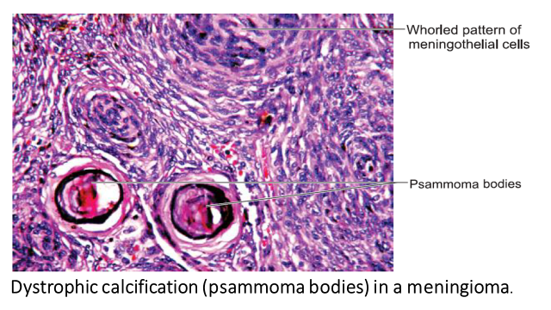

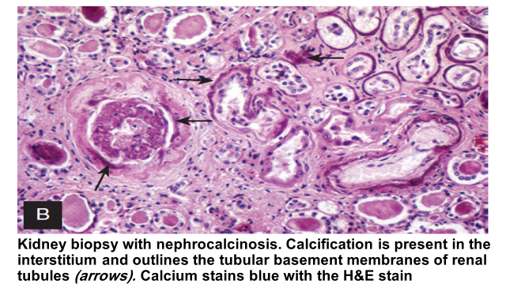

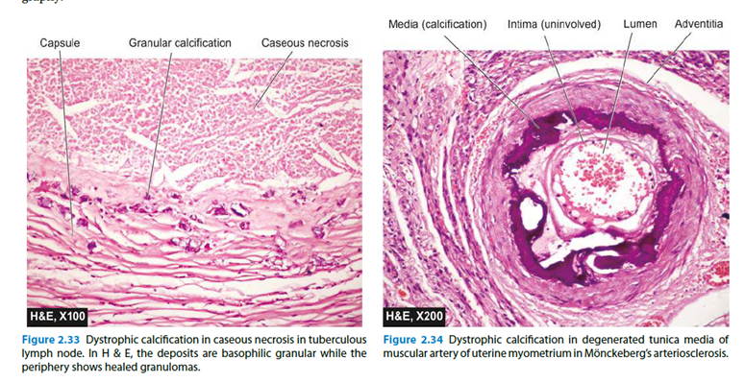

Pigmentation
- Pigments are colored substances and can be seen without staining, some of which are normal constituents of cells (e.g., melanin), whereas others are abnormal and accumulate in cells.
- The deposition of pigments in tissues in a form that can be observed visually or by microscope
- In pathology, pigments play an important role in the diagnosis of diseases such as gout, jaundice, melanomas, albinism and haemorrhage
- Types of pigmentation
- 1- Exogenous pigments
- 2- Endocous pigment p.
Exogenous pigment
(a) Inhaled pigments: The most common inhaled pigment is carbon; others include silica, iron and asbestos. Inhaled carbon is taken up by alveolar macrophages and may settle in the lungs or may be carried by lymphatics to hilar lymph nodes.
(b) Ingested pigments: Chronic ingestion of metals can cause the following conditions:
(i) Argyria: Due to chronic ingestion of silver; causes brownish pigmentation of skin, bowel and kidney.
(ii) Chronic lead poisoning: Blue pigmentation on teeth at gum line is a feature of chronic lead poisoning.
(iii) Melanosis coli: Pigmentation of colon associated with prolonged ingestion of cathartics.
(iv) Carotenaemia: Yellow-red discoloration of skin caused by ingestion of carrots.
(c) Injected pigments: These include India ink, cinnabar, carbon, etc., used in tattooing.
- It comes from outside the body and reaches the body in several ways such as breathing, food or skin
- The most common way to enter this hemoglobin is through the respiratory system, where it reaches the lungs and lymph nodes, where it is ingested inside the large devouring cells.
- Exogenous pigments may appear in the body from
inhalation (e.g. carbon dust), ingestion (e.g. argyria) and
by tattooing
- 1- Carbon (coal dust)
- - Carbon deposition in tissues is called anthracosis
- Carbon is ubiquitous air pollutant in urban areas.
- People at risk are miners, residents of industrial areas and animals near coal mines.

- It is the inhalation of carbon atoms in the form of dust, where it is deposited in the lungs
-When inhaled it is picked up by macrophages within the alveoli
and is then transported through lymphatic channels to the regional lymph nodes in the tracheobronchial region.
.

- - Macroscopic appearance
- Depending on the amount of carbon deposited, the lungs take on a color between gray and black.
- Accumulations of this pigment blacken the tissues of the lungs (anthracosis) and the involved lymph nodes
- The color may be in the form of spots or be diffuse
- Microscopic appearance
- carbon particles look like black grains.
- Carbon particles are observed inside the macrophages within the alveoli , lymphatic tissues and around the respiratory tracts.
- Since the carbon particles are not exciting, may be induce inflammation around the carbon deposition sites in the lungs.
- extensive deposition of carbon dust over many years in coal-miners may induce a fibroblastic reaction or even emphysema and thus cause a serious lung disease known as coal worker’s pneumoconiosis
- The pigment particles after inhalation are taken up by alveolar macrophages. Some of the pigment-laden macrophages are coughed out via bronchi, while some settle in the interstitial tissue of the lung and in the respiratory bronchioles and pass into lymphatics to be deposited in the hilar lymph nodes.
- Carbon deposition in the lungs is a permanent change

-

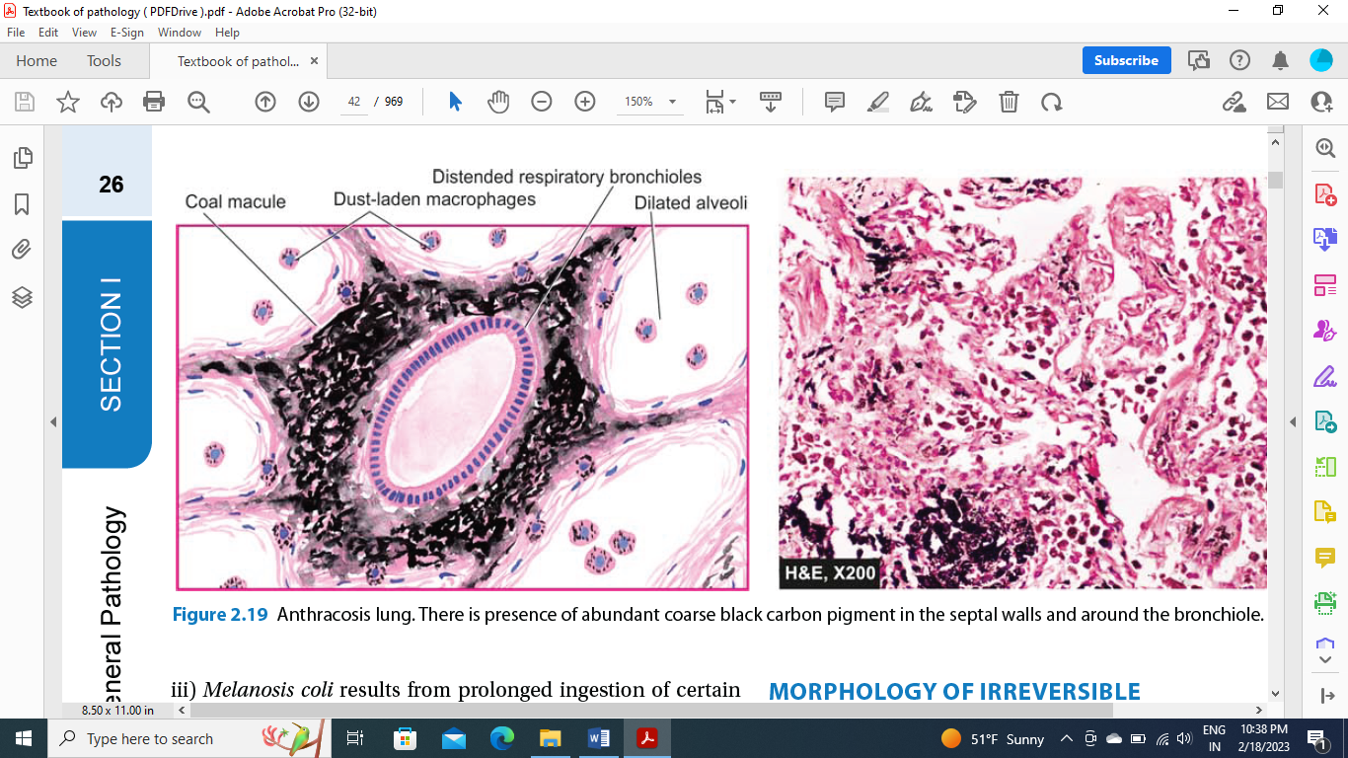

Asbestosis deposition
- It is the inhalation of asbestos and its deposit in the lungs in humans working in asbestos factories or living near it or even animals
- Macroscopic appearance
- ======
- The lungs are solid and the pleural membranes are thickened
- Precipitated asbestos appears in the form of thin egg fibers
- Microscopic appearance
- Asbestosis is marked by diffuse pulmonary interstitial fibrosis, which is indistinguishable from diffuse interstitial fibrosis resulting from other causes, except for the presence of multiple asbestos bodies. Asbestos bodies are golden brown, fusiform or beaded rods with a translucent center and consist of asbestos fibers coated with an iron-containing proteinaceous material
- They arise when macrophages phagocytose asbestos fibers; the iron is presumably derived from phagocyte ferritin. Other inorganic particulates may become coated with similar iron-protein complexes and are called ferruginous bodies. Rare single asbestos bodies
can be found in the lungs of normal people.
- It is characterized by ferruginous bodies, yellow-brown, rod-shaped bodies with clubbed ends that stain positively with Prussian blue; these arise from iron and protein coating on fibers
- Since asbestos is an exciting tissue induce the fibrosis around pleura, respiratory bronchioles and alveolar ducts and extends to involve adjacent alveolar sacs and alveoli.
-The giant macrophages cells may be observed around asbestos bodies .
- Under a polarized microscope, asbestos objects appear to be isotropic.
Prognosis
- Asbestosis may lead to lung carcinoma and mesothelioma (may involve pleura as well as peritoneum)

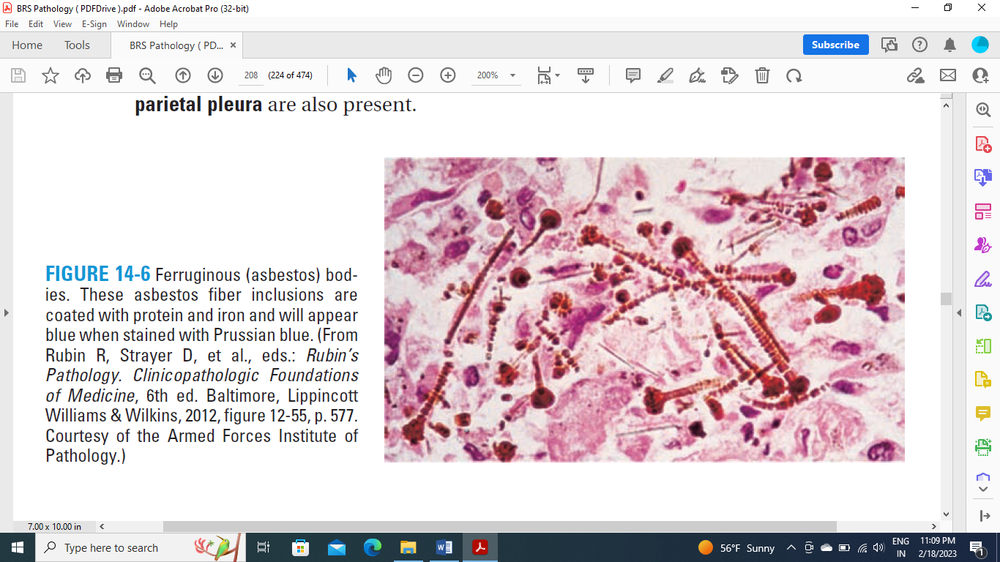

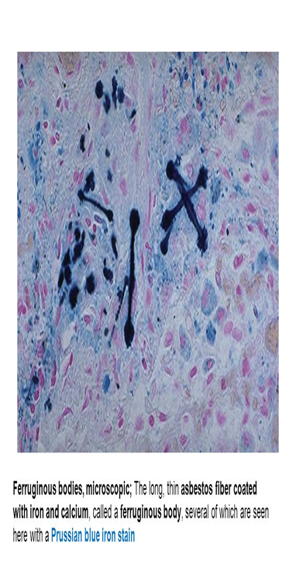

Iron deposition( Siderosis)
- Inhalation of iron dust and its deposition as form iron oxide in the lungs
- The source of exposure to iron are mines, plumbing plants and machinery
- Macroscopic appearance
- ================
- The lungs red or brown in color .
- If you put a piece of infected lung in a solution of potassium ferrocyanide and hydrochloric acid, it changes color to blue.
- Microscopic appearance
- ==================
- The precipitated iron appears as form of crystals of different sizes that are dyed blue when using Prussian blue dye
- Crystals under polarized light appear to be refractive and yellow in color
- Sometimes iron deposited as form of granules or balls may be observed inside the macrophages .
- Prognosis
- Iron deposition is a permanent change but does not pose a risk to the life of the organism
- If the inhaled dust contains silica in addition to iron, it is called the deposition of silica and iron silicosiderosis and this is dangerous because it stimulates the occurrence of fibrosis in the form of nodules or is diffuse, which may lead to heart failure or secondary infections with pneumonia bacteria or pulmonary tumors
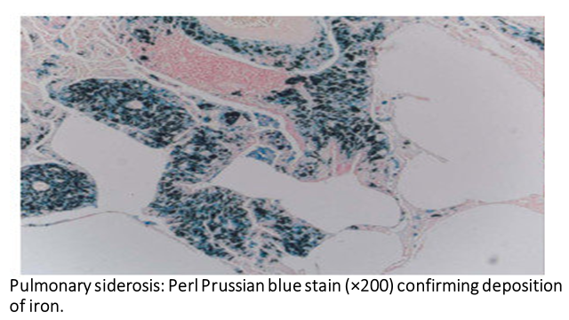

Silver deposition (Argyria or argyrosis)
- Argyria or argyrosis is a condition caused by excessive exposure to chemical compounds of the element silver, or to silver dust
- he most dramatic symptom of argyria is that the skin turns blue or blue-grey. It may take the form of generalized argyria or local argyria. Generalized argyria affects large areas over much of the visible surface of the body. Local argyria shows in limited regions of the body, such as patches of skin, parts of the mucous membrane or the conjunctiva

- Silver compounds such as argyrols are deposited in the skin, conjunctiva of the eye and other organs
- which may cause a permanent gray discoloration of the skin and conjunctivae
- Due to chronic ingestion of silver; causes brownish pigmentation of
skin, bowel and kidney
- Occurs when eating large amounts of silver compounds to treat infectious diseases

Pathophysiology

In humans and other animals, chronic intake of silver products commonly leads to gradual accumulation of silver compounds in various parts of the body
As in photography (where silver is useful because of its sensitivity to light), exposure of pale or colourless silver compounds to sunlight decomposes them to silver metal or silver sulfides. Commonly these products deposit as microscopic particles in the skin, in effect a dark pigment. This condition is known as argyria or argyrosis.
Chronic intake also may lead to silver pigments depositing in other organs exposed to light, particularly the eyes. In the conjunctiva this is not generally harmful, but it also may affect the lens, leading to serious effects.
Localised argyria often results from topical use of substances containing silver, such as some kinds of eye drops. Generalized argyria results from chronically swallowing or inhaling silver compounds, either for home medicinal purposes, or as a result of working with silver or silver compounds

- Macroscopic appearance
- It gives a gray color to the organ or tissue in which it is deposited
- Microscopic appearance
- Brown or black granules are observed inside cells such as liver cells, lungs or connective tissue
-
- Prognosis
- - Since silver is an inert substance, that is, it does not provoke inflammation in the tissue, it does not pose a danger to the life of the organism, but only the occurrence of coloring in it.
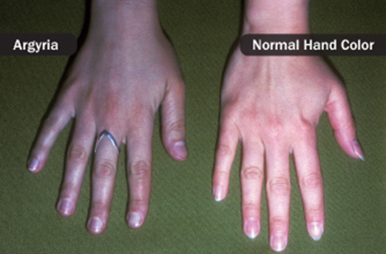

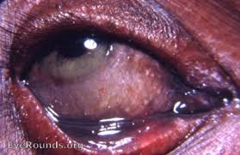

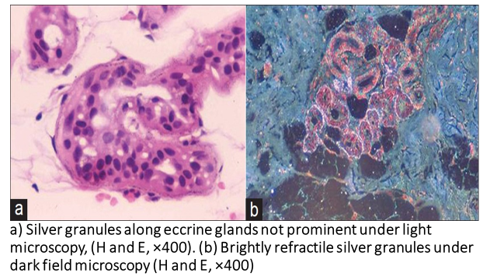

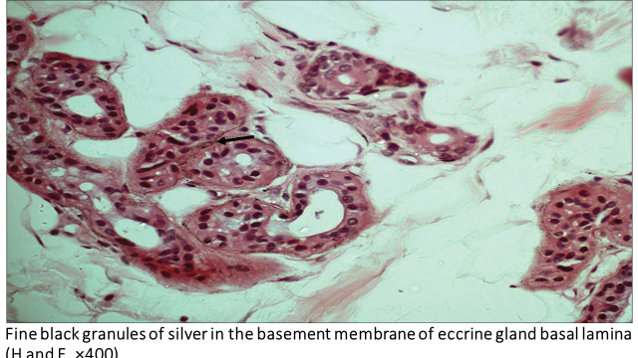

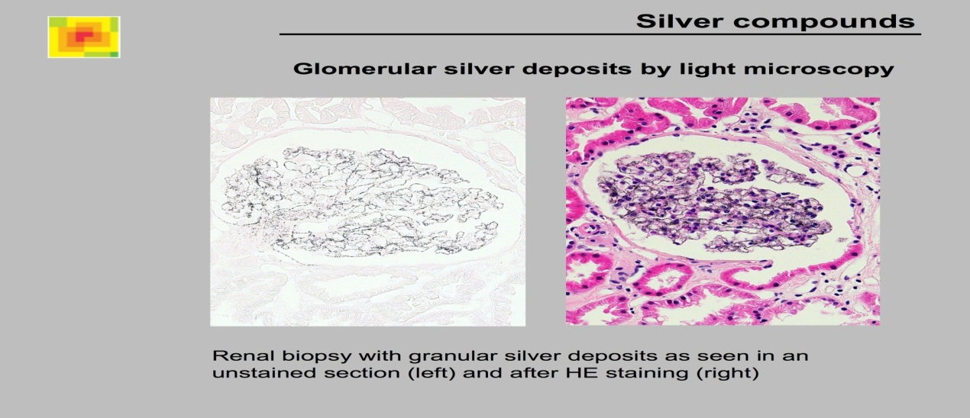

Lead deposition( plumbism )= (lead poisoning)
- Deposition of lead and hydrogen sulfide in tissues through respiration or digestive system
- Sources of lead exposure are combustion of fuel, paint, food, lead-contaminated water and lead mines
- Exposure to lead can occur by contaminated air, water, dust, food, or consumer products
- Lead poisoning poses a significantly increased risk to children as they are far more likely to ingest lead indirectly by chewing on toys or other objects that are coated in lead paint
- In humans the main sources of lead are usually lead-based paint and drinking water carried through lead pipes; lead-based paints are especially harmful to children who chew on painted toys and furnishings and eat paint peelings from walls. Industries
- In children, following are the main sources of lead poisoning:
i) Chewing of lead-containing furniture items, toys or pencils.
ii) Eating of lead paint flakes from walls.
- In adults, the sources are as follows:
1. Occupational exposure to lead during spray painting,
recycling of automobile batteries (lead oxide fumes), mining,
and extraction of lead.
2. Accidental exposure by contaminated water supply, house
freshly coated with lead paint, and sniffing of lead-containing
petrol (hence unleaded petrol introduced
as fuel).
- Lead poisoning, also known as plumbism and saturnism, is a type of metal poisoning caused by lead in the body. The brain is the most sensitive
- Most of the absorbed lead is taken up by bone and teeth
- Lead is absorbed through the gastrointestinal tract or
lungs. The absorbed lead is distributed in two types of tissues;
a) Bones, teeth, nails and hair representing relatively harmless
pool of lead. About 90% of absorbed lead accumulates
in the
developing metaphysis of bones in children and appears as
areas of increased bone densities (‘lead lines’) on X-ray. Lead
lines are also seen in the gingiva.
b) Brain, liver, kidneys and bone marrow accumulate the
remaining 10% lead which is directly toxic to these organs. It is
excreted via kidneys.
Effects of Lead Poisoning
1. Bones: Radiodense deposits in epiphyses (excess lead interferes with vitamin D metabolism
and calcium homoeostasis thereby interfering with normal remodelling of
calcified cartilage and primary bone trabeculae in the epiphyses of children)
2. Nervous system: Excess lead causes neurological effects in adults and children
(encephalopathies, demyelination, peripheral neuropathies, low intellectual capacity,
hyperactivity, poor organizational skills, headache and memory loss)
3. Gingiva: Lead line (lead stimulates hyperpigmentation of the gums)
4. Blood: Lead has high affinity for sulphydryl groups and interferes with enzymes
involved in haem synthesis; iron incorporation into haem is impaired leading to
microcytic hypochromic anaemia and basophilic stippling. The levels of erythrocyte
protoporphyrin are increased.
5. Kidney: Chronic tubulointerstitial disease (excretion of lead occurs via the kidney)
6. GIT: Abdominal pain or colics
Lead toxicity occurs in the following organs predominantly:
1. Nervous system The changes are as under:
i) In children, lead encephalopathy; oedema of brain,
flattening of gyri and compression of ventricles.
ii) In adults, demyelinating peripheral motor neuropathy
which typically affects radial and peroneal nerves resulting in
wristdrop and footdrop respectively.
2. Haematopoietic system The changes in blood are quite
characteristic:
i) Microcytic hypochromic anaemia due to inhibition of two
enzymes: delta-aminolevulinic acid dehydrogenase required
for haem synthesis, and through inhibition of ferroketolase
required for incorporation of ferrous iron into the porphyrin
ring.
ii) Prominent basophilic stippling of erythrocytes.
3. Kidneys Lead is toxic to proximal tubular cells of the
kidney and produces lead nephropathy characterised by accumulation of intranuclear inclusion bodies consisting of
lead-protein complex in the proximal tubular cells.
4. Gastrointestinal tract Lead toxicity in the bowel
manifests as acute abdomen presenting as lead colic.
- Macroscopic appearance
- The tissues are colored blackish-blue, especially those that contain hormone sulfate, such as the gums, because here the remnants of food particles are decomposed by bacteria at the base of the teeth, forming hydrogen sulfate, which is one of the signs of chronic lead poisoning, and this is in the form of a line called the blue line.
- blue pigmentation on teeth at gum line is a feature of chronic lead poisoning.
-
- Microscopic appearance
- Lead deposited in tissues cannot be seen with normal preparations
- Its pathological effects can be studied in histological sections

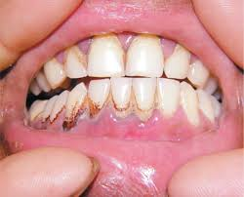

Tattoo= Injected Pigments (Tattooing)
- Injected pigments: These include India ink, cinnabar, carbon, etc., used in
tattooing
- Pigments like India ink, cinnabar and carbon are introduced
into the dermis in the process of tattooing where the pigment is
taken up by macrophages and lies permanently in the connective
tissue. Th e examples of injected pigments are prolonged
use of ointments containing mercury, dirt left accidentally in a
wound, and tattooing by pricking the skin with dyes.
- Introducing different types of dyes such as turmeric, Indian ink or Chinese ink into the dermis and subdermis
- Appearancely, the change can be observed with the naked eye
- Tattooing is a form of localized, exogenous pigmentation of the skin. The pigments inoculated are phagocytosed by dermal macrophages, in which they reside for the remainder of the life of the embellished
(sometimes with embarrassing consequences for the bearer of the tattoo when proposing to Mary while the tattoo says Valerie!). The pigments do not usually evoke any inflammatory
Response

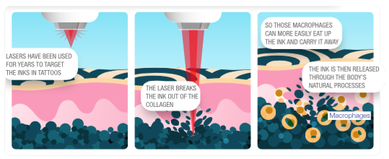

- Microscopic appearance
- - The presence of pigments is observed within the large phalgesic cells in the tissues
- These cells may be out of the connective tissue
- These dyes are inert and may not provoke inflammation in the tissue, but secondary infection with bacteria or tumors may occur.

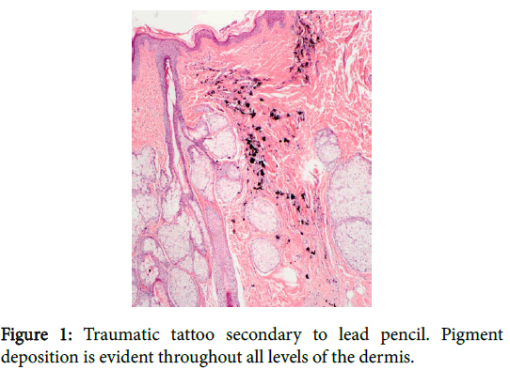

Endogenous Pigments

1- Melanin
-Melanin is an endogenous, brown-black, non-hemoglobinderived pigment. It is produced by the melanocytes and dendritic cells by the oxidation of tyrosine to dihydroxyphenylalanine by the enzyme tyrosinase. It is stored as cytoplasmic granules in the phagocytic cells namely melanophores.
- This pigment is synthesized in melanosomes of melanocytes within the epidermis, and transferred by melanocytes to adjacent clusters of keratinocytes and also to macrophages (melanophores) in the subjacent dermis.

- Normally, it is present in the hair, skin, mucosa at some places, choroid of the eye, meninges and adrenal medulla.
-- Melanin is responsible for the black color of hair, eyes, skin and meninges
-Various disorders of melanin pigmentation produce generalized and localized hyperpigmentation and hypopigmentation
- Increased melanin pigmentation is associated with sun tanning and with a wide variety of disease conditions.
- Decreased melanin pigmentation is observed in albinism and vitiligo

Staining characteristics of melanin:
- Can be bleached with hydrogen peroxide and stained with Masson–Fontana argentaffin stain; this forms the basis of differentiation of melanin from melanin lookalikes, eg, homogentisic acid seen in alkaptonuria and carbon seen in anthracosis
- For practical purposes melanin is the only endogenous brown-black pigment. The only other that could be considered in this category is homogentisic acid, a black pigment that occurs in patients with alkaptonuria, a rare metabolic disease. Here the pigment is deposited in the skin, connective tissue, and cartilage, and the pigmentation is known as ochronosis.

- Increased secretion of pituitary and ACTH hormone causes increased secretion of melanin and this explains the discoloration of the skin of people with Edison's disease as well as in pregnant women
- Under normal circumstances, the adrenal gland converts melanin into epinephrine, but when this gland is disturbed in diseases such as tuberculosis, hypermelanin is produced.
- Melanin dye gives the tissues in which it is present black or brown color depending on the amount of dye, its distribution and the type of tissue
- The distribution of melanin may be as widespread as in the skin of dark skin.
- Or be in the form of foci as in people with millitumors
- Under the microscope, melanin appears as tiny spherical grains of brown color inside or outside cells, usually found in the cytoplasm of melanoblast cells and melanin carriers.

melanin disorder
- 1- Albinism
- - In which the patient is partially or completely missing the melanin and because of the absence of an enzyme Tyrosinase genetically
- As a result of the absence or lack of melanin, people with albinism suffer from skin burns when exposed to sunlight.
- 2- Vitiligo or leukoderma
- The presence of skin patches that do not contain melanin
- The main cause is unknown and is thought to be healed patches without the presence of meloblastic cells.
- 3- freckles
- They are saturated patches with melanin in the skin that become dark in color when the patient is exposed to sunlight because the sun's rays alert the melanocytes to produce melanin
- 4- Moles
- Benign melanotic tumours originating from melanotic cells
- 5- Malignant melanocarcinomas originating from melanocarcinomas

Melanosis
- A congenital disease caused by the unusual migration of melanocytes and their collection in the form of foci in the intestines, heart, lungs, kidneys and mammary glands
- Melanocytes may collect in the mucous membrane of the large intestine and colon, causing melanosis coli
-
ochronosis
-Homogentisic acid is a pathological black pigment formed in rare metabolic autosomal recessive disorder termed alkaptonuria.
-It is characterized by deficiency of an oxidase enzyme needed for breakdown of homogentisic acid.
-This leads to accumulation of homogentisic acid pigment in
the skin, connective tissue, cartilage, capsules of joints,
ligaments and tendons.
-The pigment is melanin-like and the pigmentation is known as ochronosis. -The homogentisic acid is excreted in the urine (homogentisic aciduria).
-The urine of patients of alkaptonuria, if allowed to stand for some hours in air, turns black due to oxidation of homogentisic acid.

lipofuscin =“wear-and-tear” pigment= Lipopigments
- -This yellowish, fat-soluble pigment is considered one of the aging dyes or wear-and-tear pigment(Lipid-derived wear and tear pigment
-Lipofuscin is an insoluble pigment, also known as lipochrome
- The combination of lipofuscin accumulation and atrophy of organs is referred to as brown atrophy(associated with atrophied cells of old age and wasting).

- Lipofuscin is composed of polymers of lipids and phospholipids in complex with protein, suggesting that it is derived through lipid peroxidation
of polyunsaturated lipids of subcellular membranes( end product of membrane lipid peroxidation).

- Sometimes called ‘residual bodies’ (collection of indigestible material in the lysosomes after intracellular lipid peroxidation)
- In tissue sections it appears as a yellow-brown, finely granular intracytoplasmic (perinuclear in location).
-- These pigments dissolve in fat with difficulty and are produced from oxidizing and unsaturated fatty acids and are produced from the cells of the body and not from food
- When the pigment is present in large quantities in the tissues, it is covered in brown color and can be seen with the naked eye, so it is sometimes called brown atrophy in the heart and liver in the old age.
- this pigment appears in the cardiac muscle fibers in the form of granules in the cytoplasm near the nucleus, and the lysosomes break down the membranes of the organelles containing this dye, where they can be seen under the electron microscope the lipofuscin surrounded by lysosomes
- It is seen in cells undergoing slow, regressive changes and is particularly
prominent in the hepatocytes and myocardium , Leydig cells and neurons of aging patients or patients with severe malnutrition and cancer cachexia.
Staining characteristics of lipofuscin:
• Acid fast (AFB positive)
• Autofluorescent
• Stains positive with fat stains
• Reduces ferricyanide to ferrocyanide (Schmorl reaction)

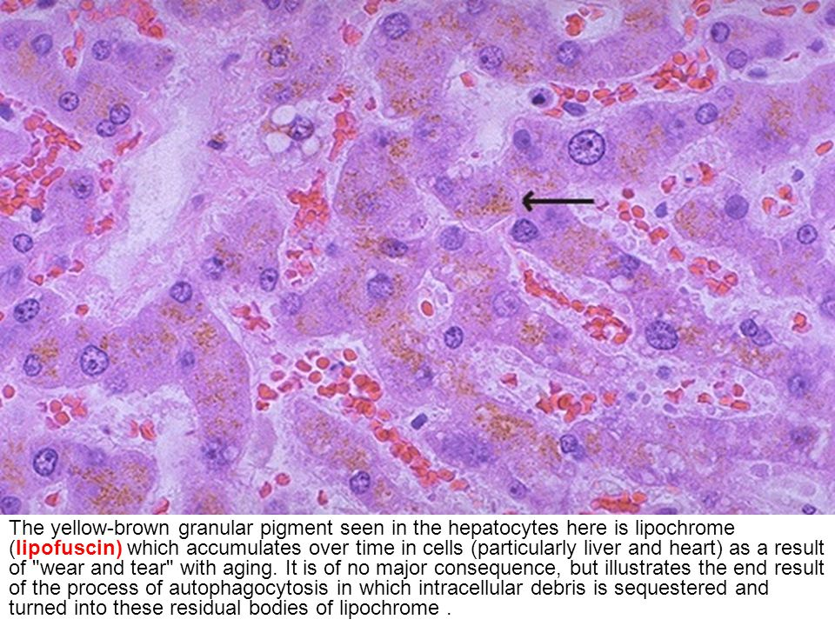

Pigments derived from haemoglobin
- hemoglobin acts to transport oxygen your body receives to all body tissue via blood vessels. Over time, when red blood cells need to be replenished, the hemoglobin is broken down in the spleen; it breaks down into two parts: heme group consisting of iron and bile and protein fraction. While protein and iron are utilized to renew red blood cells, pigments that make up the red color in blood are deposited into the bile to form bilirubin.
- In hemolytic diseases accompanied by excessive of breakdown of red blood cells, bilirubin are released in the serum and tissue fluids and its colored with reddish-yellow
- It is not possible to observe hemoglobin under the microscope in red blood cells or tissues, but the porallization of hemoglobin in renal renal tubules in pathological cases leads to the formation of cylinders or casts that can be observed under the microscope when dyeing sections with routine dyes, where they appear as granular cylinders with red or orange color , as in hemolytic anemia, where hemoglobin in serum passes through glomerular filtration in quantities that exceed the ability of the renal tubules to reabsorb it. So it porallizes as form of cylinders inside the cells of the renal tubules.

Hemosiderin
- This iron-containing pigment consists of aggregates of ferritin
- It is a hemoglobin-derived, golden yellow-to-brown, granular or crystalline pigment which stains with Prussian blue stain
- its one of the major Russel bodies storage forms of iron.
-Haemosiderosis is defined by accumulation of hemosiderin(stainable iron), primarily within tissue macrophages, reticulocytes and epithelial cells in the liver and kidneys without associated tissue or organ damage.
- It exists normally in small amounts as physiologic iron stores within tissue macrophages of the bone marrow, liver, and spleen.and It accumulates pathologically in tissues in excess amounts.
- Iron is normally carried by specific transport protein called transferrin. In cells, it is stored in association with a protein, apoferritin, to form ferritin micelles. Ferritin is a constituent of most cell types. When there is a local or systemic excess
- of iron, ferritin forms hemosiderin granules, which are easily seen with the light microscope. Hemosiderin pigment represents aggregates of ferritin micelles. Under normal conditions small amounts of hemosiderin can be seen in the
- mononuclear phagocytes of the bone marrow, spleen, and liver, which are actively engaged in red cell breakdown.
- Causes
- Absorption of large amounts of iron in the intestines
- Hemolytic diseases
- - Old bleeding sites
- - Chronic heart failure leads to local accumulation of hemosiderin in the kidneys

- Types of Haemosiderosis
Local or systemic excess of ferritin (iron) cause hemosiderin to accumulate within cells.
•• Localized: deposits in macrophages, fibroblasts, endothelial and alveolar cells secondary to haemorrhage in tissues, eg, bruise, black eye, brown induration of lung and infarction.

•• Systemic: deposits in reticuloendothelial cells or microphages (liver, spleen, bone marrow) or parenchymal organs (liver, pancreas, kidney, heart) secondary
to haemolytic disorders, Repeated blood transfusions, parenteral iron therapy, idiopathic haemosiderosis and Bantu disease. Systemic overload of iron is known as hemosiderosis, Increased absorption of dietary iron, Excessive destruction of red cells: For example, hemolytic anemias and
- Hemochromatosis is more extensive accumulation of hemosiderin(iron overload), often with in parenchymal cells, leading to fibrosis and organ dysfunction. This condition occurs in both hereditary (primary) and secondary forms.
- Hereditary hemochromatosis is most often caused by a mutation in the
Hfe gene on chromosome 6. Over 20 distinct mutations have been identified,
the most common of which is the C282Y mutation, followed by the H63D
mutation.
- Hemosiderin deposition and organ damage in the liver, pancreas,
myocardium, and multiple endocrine glands is characteristic, as well as
melanin deposition in the skin.
- This results in the triad of micronodular cirrhosis, diabetes mellitus, and
skin pigmentation. This set of findings is referred to as “bronze diabetes.”

Macroscopy:
- The presence of hemosiderin in the tissues cannot be seen with the naked eye

Microscopy:
- hemosiderin appears as a granular yellow-brown pigment of different sizes within the cytoplasm the endothelial reticulocytes of the spleen, liver, bone marrow and lymph nodes.
-presence of hemosiderin inside the macrophages at the site of bleeding give brown colors to the tissue.
- To make sure that the pigment in the tissue is hemosiderin, the sections staining with blue Prussian, which colors the iron in blue black .
-Prussian blue (Perl’s stain) histochemical reaction in which hemosiderin converts colorless potassium ferrocyanide to blue-black ferric ferrocyanide.
- The presence of hemosiderin in the tissues is not dangerous to the organism, but it gives an indication of the presence of lysis in red blood cells or the absorption of large amounts of iron due to a defect in the intestines, or the presence of hemosiderin locally indicates the presence of old bleeding in the tissue.

Hematoidin
- is a type of endogenous pigment derived from hemoglobin (specifically from protoporphyrin IX) that forms under conditions with low or no oxygen concentration.
- A crystalline or amorphous pigment, free from iron, formed from hematin in old blood stains, and in old hemorrhages in the body.
- -Unlike hemosiderin, these crystals do not contain iron, and as such, they are not highlighted by stains such as Perls and Prussian blue. –
- Hematoidin is observed with light microscopy as refractive crystals, and under polarized light, it may have positive or negative birefringence.
- - Hematoidin has a golden-brown crystalline pigmentation and is composed of thread-like filaments arranged in star-shaped clusters
- - Hematoidin crystals (HCs) may be intra or extracellular; may display a range of morphology, most frequently, a star like or rhomboidal/rectangular shape arranged in a radial pattern; and/or manifest as individual needles that measure 8–10 μm in size and exhibit golden, brown-yellow, or yellowish reddish coloration
- HCs are soluble in chloroform but insoluble in water, alcohol, and ether.
- HCs are often found in body cavities containing old blood and organizing hematomas
- - the presence of HCs in cytopathology, mainly in cervicovaginal smears from pregnant women or pregnancy-like states. In such cases, HCs are also known as “cockleburs.”
- - Hematoidin forms when erythrocyte extravasation occurs in a closed tissue compartment and is a result of hemoglobin metabolism under low oxygen tension conditions. Following erythrocyte degeneration, porphyrin is released from hemoglobin and is converted to biliverdin, which is reduced to crystalline hematoidin. Because hematoidin can be converted back to biliverdin, it is not always seen

- Acid haematin (haemozoin) Haemoprotein-derived brown-black pigment seen in malaria.and Does not stain with Prussian blue (because iron is in ferric form).
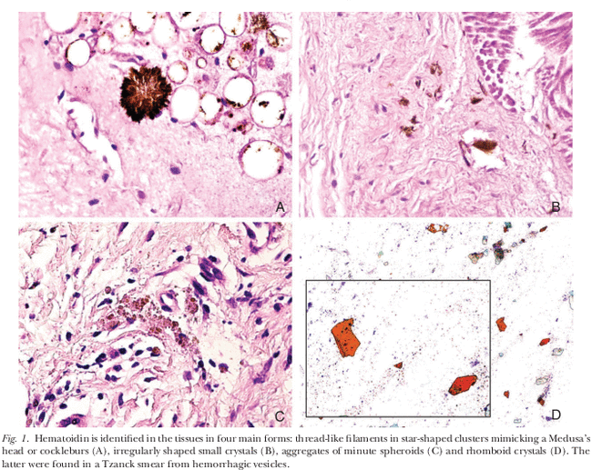

Bilirubin
- Major pigment found in bile (Fig. 1.18), stains with Gmelin reaction (oxidation by concentrated nitric acid to red/blue-green products) and Stein’s technique (oxidation by iodine to form a green biliverdin pigment).
- Derived from haemoglobin but contains no iron.
- In various pathologic conditions, bilirubin accumulates and stains the blood, sclerae, mucosae, and internal organs, producing a yellowish discoloration called jaundice.
- Hemolytic jaundice, which is associated with the destruction of red cells,
- Hepatocellular jaundice, which is associated with parenchymal liver damage, and obstructive jaundice, which is associated with intra- or extrahepatic obstruction of the biliary tract,
- Bilirubin (bil-ih-ROO-bin) is a yellowish pigment that is made during the breakdown of red blood cells. Bilirubin passes through the liver and is eventually excreted out of the body.
- Normally, bilirubin joins with bile in the liver, moves through the bile ducts into the digestive tract, and is eliminated from the body. Most bilirubin is eliminated in stool, but a small amount is eliminated in urine.
- Higher than usual levels of bilirubin may indicate different types of liver or bile duct problems. Sometimes, higher bilirubin levels may be caused by an increased rate of destruction of red blood cells.
- In the case of jaundice, due to the presence of a large breakdown of red blood cells, bilirubin leaks in large quantities into the tissues and tissue fluids.
- There are two types of bilirubin deposition
- 1- Local deposition
- Observed at walled-off hemorrhage sites of erythrolysis products damaged by macrophages.
- With cholestasis, the flow of bile is impaired at some point between the liver cells (which produce bile) and the duodenum (the first segment of the small intestine). When bile flow is stopped, the pigment bilirubin (a waste product formed when old or damaged red blood cells are broken down) escapes into the bloodstream and accumulates.
- causes of CHOLESTASIS is blockage of the bile ducts outside of liver or bile canaliculi within liver.
- CHOLESTASIS as LOCAL DEPOSITION OF BILIRUBIN IN THE LIVER CAN BE observed microscopy . its appear as yellow filamentous plugs in bile canaliculi within liver tissue or yellow microgranulars in cytoplasm of liver cells .
2- General deposition
- General deposition of bilirubin is observed in cases of jaundice
- Jaundice is a yellow color of that results from hyperbilirubinemia( excess bilirubin deposited in the the mucous membrane , skin and eyes, and dark urine results from excess bilirubin excreted by the kidneys ).
- Jaundice becomes visible when the bilirubin level is about 2 to 3 mg/dL (34 to 51 micromol/L)
- The diagnosis of jaundice is based on the presence of bilirubin in
body fluids and not the examination of tissue sections.

